00000000000000000000000000000000000000000000000000000000000000000000000000000000000000000000000000000000000000000000000000

JC Rupe

Date: **May 18, 2017**

Version: **1.0.3**



**Project JIM:**

*Charge on Credit Card*

**IT Project Management Office**

Document Revisions

|  |  |  |
| --- | --- | --- |
| Date | Version Number | Document Changes |
| 2016/12/14 | 1.0.0 JC | Document initial creation/completion. Made a minor correction. |
| 2017/01/12 | 1.0.1 JC | Edited a small amount of the wording. Section 1.1.  Added Voiding a charge, made other changes and corrections around doc. |
| 2017/01/17 | 1.0.2 JC | Made corrections. Added document name to footer. |
| 2017/05/18 | 1.0.3 | Update to JIM. Add Credit Card receipt by email. |
|  |  |  |
|  |  |  |

Contents

1 How to Charge on Credit Card 3

1.1 Important Information 3

1.2 Contact ePayment Wallet 3

1.2.1 Create Customer Contact ePayment Wallet 3

1.2.2 Add a Credit Card to the Contact ePayment Wallet 4

1.2.3 Disable a Credit Card in Wallet 6

1.3 Payments 7

1.3.1 Make a Payment 7

1.3.2 View a Contacts Payment History 10

1.3.3 View all ePayment Transactions 11

1.3.4 Void a Payment 12

1.3.5 Results of Voiding a Transaction the Next Day 12

1.3.6 Credit Card Receipt by Email 13

1.3.7 Verify Credit Card Receipt Sent by Email 13

# How to Charge on Credit Card

This document explains how to enter a Contacts credit card(s) into the JIM system and how to place charges against the Contacts credit card.

## Important Information

* **Selecting a record, not a link in the record:** Try to select a part of the record line that doesn’t contain a link. Remember, text displayed in blue is a link. If you click on the link, it will open that items information page. For example if you select the name of the Contact, the Contact information page in JIM will open. If this happens, you may have to navigate back to the previous page or close the window that opened when you selected the link.
* The preferred browser to use is Microsoft Explorer, although, Chrome and Firefox should also work.
* In this document, the references to Contact and Customer are the same person.
* For assistance with record table view navigation, see the steps in section “Navigation of a Record View” section of the “JIM – Customer Service Reference Guide” document.
* For assistance with searching and filtering of records, see the steps in section “Search & Filter Record View” section of the “JIM – Customer Service Reference Guide” document.
* A charge card payment may only be voided on the day the transaction was entered into the system.

## Contact ePayment Wallet

### Create Customer Contact ePayment Wallet

|  |
| --- |
| **Important:** Only create a Contacts/Customers EPayment Wallet through the “Contact” page.  Follow the below steps to successfully create a Contact/Customer EPayment Wallet. |

1. Navigate to the Contact page
   1. **Note:** This is one way to get to the Contact page. What is important is to create the EPayment Wallet from the Contact page.
      1. Select the “Main” menu button.
      2. Select the “Service” Work Area.
      3. Locate and select the “Contacts” icon under the “Service” column.
      4. The default Contacts View page will appear.
      5. Enter search criteria to locate the desired Contact/Customer.
      6. Open the Contact record, by clicking on the Contact “Full Name” or by double clicking on the Contact record.
2. The “Contact” page will display.
3. Select the dropdown arrow to the right of the Contacts name, in the top navigation bar.



1. Select the “ePayment Wallet” option, from the dropdown menu.



1. The “Credit Card Associated View” page will display.

### Add a Credit Card to the Contact ePayment Wallet

1. Navigate to the “Credit Card Associated View” page.
2. Select the “Add New Epayment Wallet” option, above the account table grid.

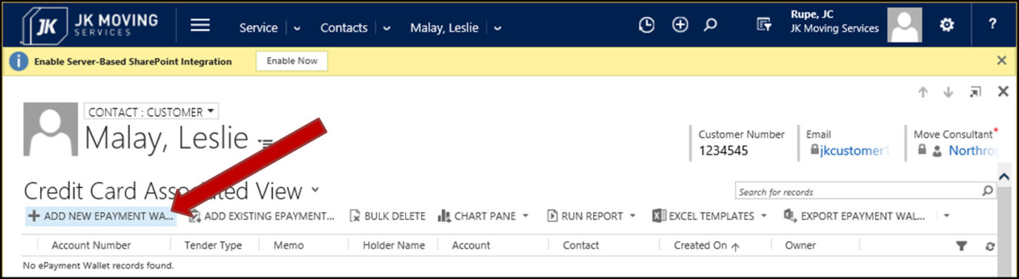

1. The “New ePayment Wallet” window will display, in a separate window.
   1. This may take a few extra moments to display.

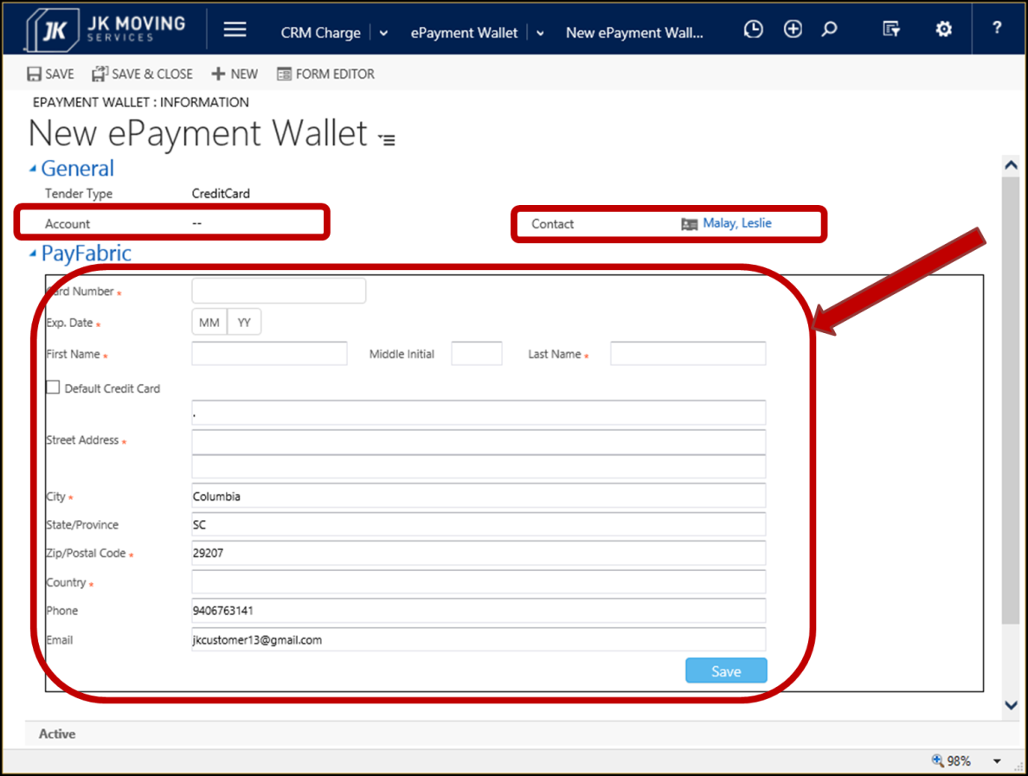

1. The “General” panel will already be populated with appropriate information.
   1. Tender Type: CreditCard
   2. Account – This is the Employer of the Contact. This field should not contain any data. If there is data here, do not save the Credit Card into the Wallet.
2. Enter appropriate data into the “PayFabric” panel.
   1. Required data:
      1. Card Number – Enter the entire 16 digit charge card number.
      2. Exp. Date – Enter the credit card expiration data.
      3. First Name – The first name of the card holder, as it appears on the credit card.
      4. Last Name – The last name of the card holder, as it appears on the credit card.
      5. Street Address – The credit card billing street address. There are 3 fields for the entry of the “Street Address”.
      6. City – The credit card billing address city.
      7. Zip/Postal Code – The credit card billing address zip/postal code.
      8. Country – The credit card billing address country.
   2. Optional data:
      1. Middle Initial – The credit card holders middle initial.
      2. Default Credit Card – Checking the box indicates that this is the default (primary) credit card.
      3. State/Province – The credit card billing address state or province.
      4. Phone – The Contacts phone number, where they may be reached.
      5. Email – The Contacts email address, where they may be reached.
3. Select the “Save” button.
4. The “Epayment Wallet” page will display.
   1. Note that the “Account” field must be empty.
   2. Notice that the “Owner” is the person who entered the credit card information into the wallet.

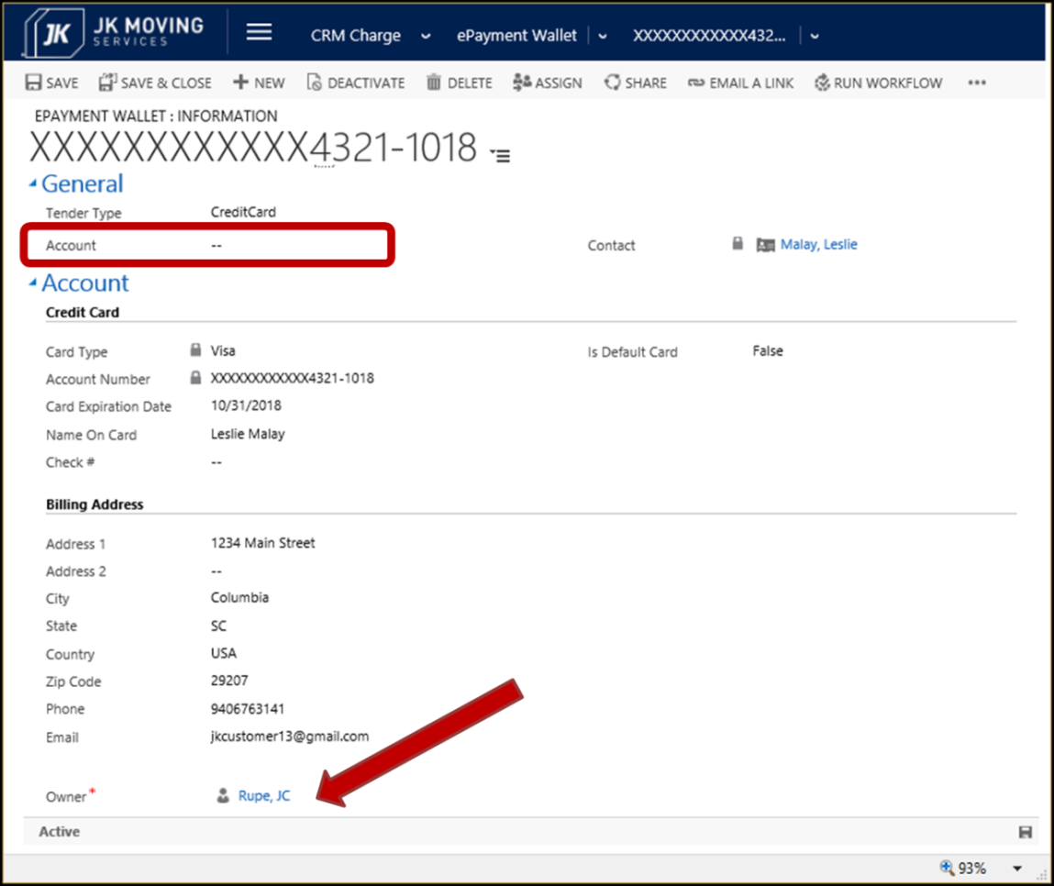

1. Close the “Epayment Wallet” page window.
2. The “Credit Card Associated View” should display with the newly created charge account record listed in the table grid.

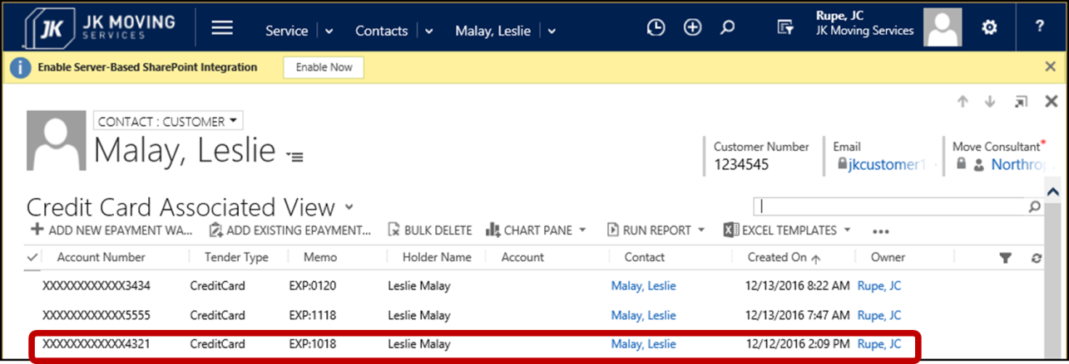

### Disable a Credit Card in Wallet

|  |
| --- |
| **Important:** Never Delete Credit Card(s) from wallet.  Only Deactivate Credit Card(s). |

1. Navigate to the “Credit Card Associated View” page.
2. Select the Credit Card record(s) to be disabled.
   1. Each record selected will have a check mark on the left and the row will be highlighted.

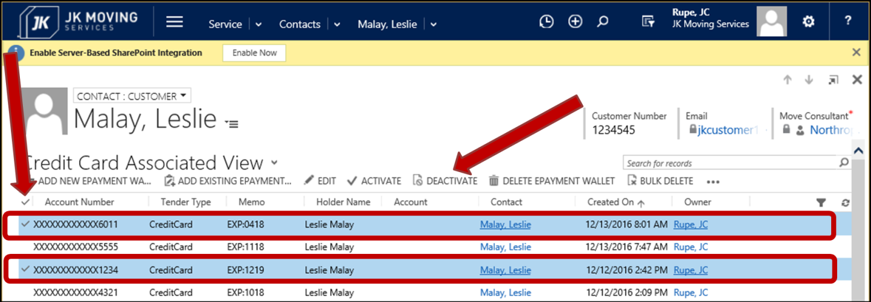

1. Select the “Deactivate” option, above the account table grid.
2. The “Confirm Deactivation” box will display

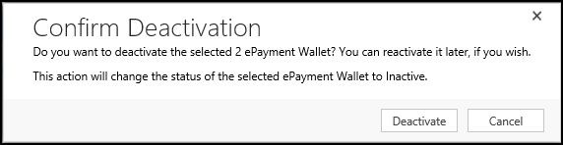

1. Select the “Deactivate” button.
2. The deactivated Credit Card record(s) will disappear from the record grid on the “Credit Card Associated View” page.

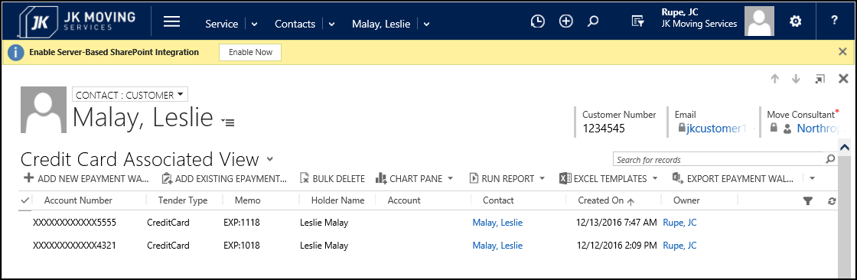

## Payments

### Make a Payment

**Notes:**

* In the below steps, payment is being made from the **Move** page. The steps are mostly the same when making a payment from the **Contact** page.
* When you create a Payment from the **Move** page: The “Regarding” field is automatically populated with the Move name and ID.
* When you create a Payment from the **Contact** page: The user must search for the appropriate Move information to be placed into the “Regarding” filed.

1. Navigate to the desired “Move: Information” page.
   1. See the steps in section “Navigate to Moves” section of the “JIM – Customer Service Reference
2. The “Move” page will display.
3. Select the “More Commands” option in the upper navigation bar. 

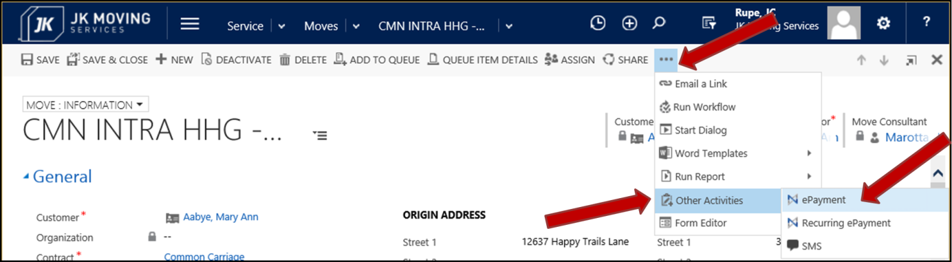

1. Select the “Other Activities” option, from the drop down menu.



1. Select the “ePayment” option, from the next dropdown menu.



1. The “New ePayment” page will display, in a separate window.
2. Enter appropriate data into the form.
   1. Above the ePayment Details panel:
      1. These fields will be auto-populated after transaction is successfully processed.
         1. Card Name – The financial institution backing the charge card. i.e. Master Card, Visa and etc.
         2. Masked Account – The charge card account number with most of it masked.
         3. Expiration Date – The charge card expiration date.
   2. ePayment Details panel:
      1. Required data:
         1. **Regarding** – This field may be auto-populated. Otherwise, search for and select the appropriate Move.
         2. **Transaction Type** – Select the type of transaction.
            1. Book
            2. Sale
            3. Cash/Check
         3. If “Transaction Type” is **Book** or **Sale** then select a value for the “Gateway” field.
            1. **Gateway** – This is auto-populated with the gateway “AuthorizeNet”.
         4. If “Transaction Type” is **Book** or **Sale** then enter a “Wallet” value.
            1. **Wallet** – Select which Charge Card to use from the Contacts Wallet.
         5. **Amount** – Enter the total dollar amount for this transaction.
      2. Optional data:
         1. **Comment** – Enter any necessary comments.
         2. If “Transaction Type” is **Book** or **Cash/Check** then a value may be entered for the “Check Number” field.
            1. **Check Number**
         3. If “Transaction Type” is **Sale** then a value may be entered for the “Card Security Code” field.
            1. **Card Security Code** – This is the 3 digit security code found on the back of the charge card.
      3. Supporting Fields sub-panel:
         1. **Transaction Date** – This is auto-populated with today’s date.
         2. **Owner –** A required field that is auto-populated with the name of the person entering the payment. This value may be changed by searching for another person to assign as the Owner.
         3. **Payment Status** – This field is auto-populated with the value “Open”. It shows the current status of the payment.
         4. **Auth Code** – Enter the Authorization Code, if there is one.
   3. Notes panel: These fields will be auto-populated after transaction is successfully processed.
      1. **Transaction** **ID**
      2. **PayFabric Auth** **Code**
      3. **PayFabric** **Result** **Code**
      4. **PayFabric** **Result** **Message**
   4. Pictured here is the form for “Transaction Type” **Sale**.

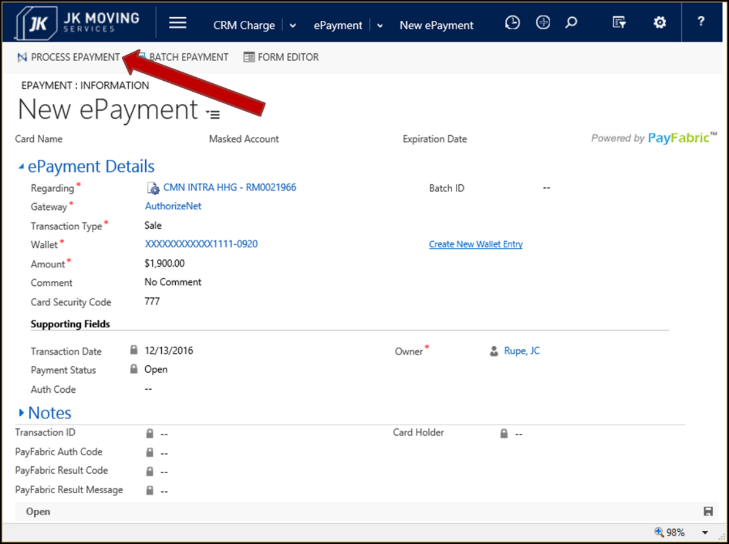

1. Select the “Process ePayment” button in the form navigation bar.
   1. Since it may take a little while to process, a message saying “Processing ePayment…” may display.

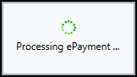

1. A message box will display, when the charges are successfully processed.

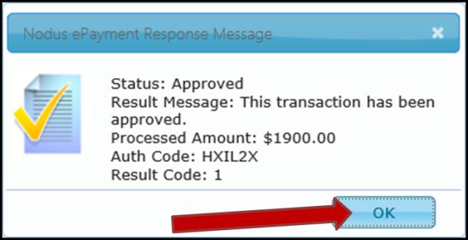

* 1. Verify that the Status is “Approved”.
  2. The “Auth Code” will be displayed within the message box.
  3. Select the “OK” button.

1. The “ePayment” page will redisplay with the completed transaction.
   1. The Card Name, Masked Account and Expiration Date are now populated.
   2. The Supporting Fields are now updated or populated.
   3. The Notes panel fields are now populated.

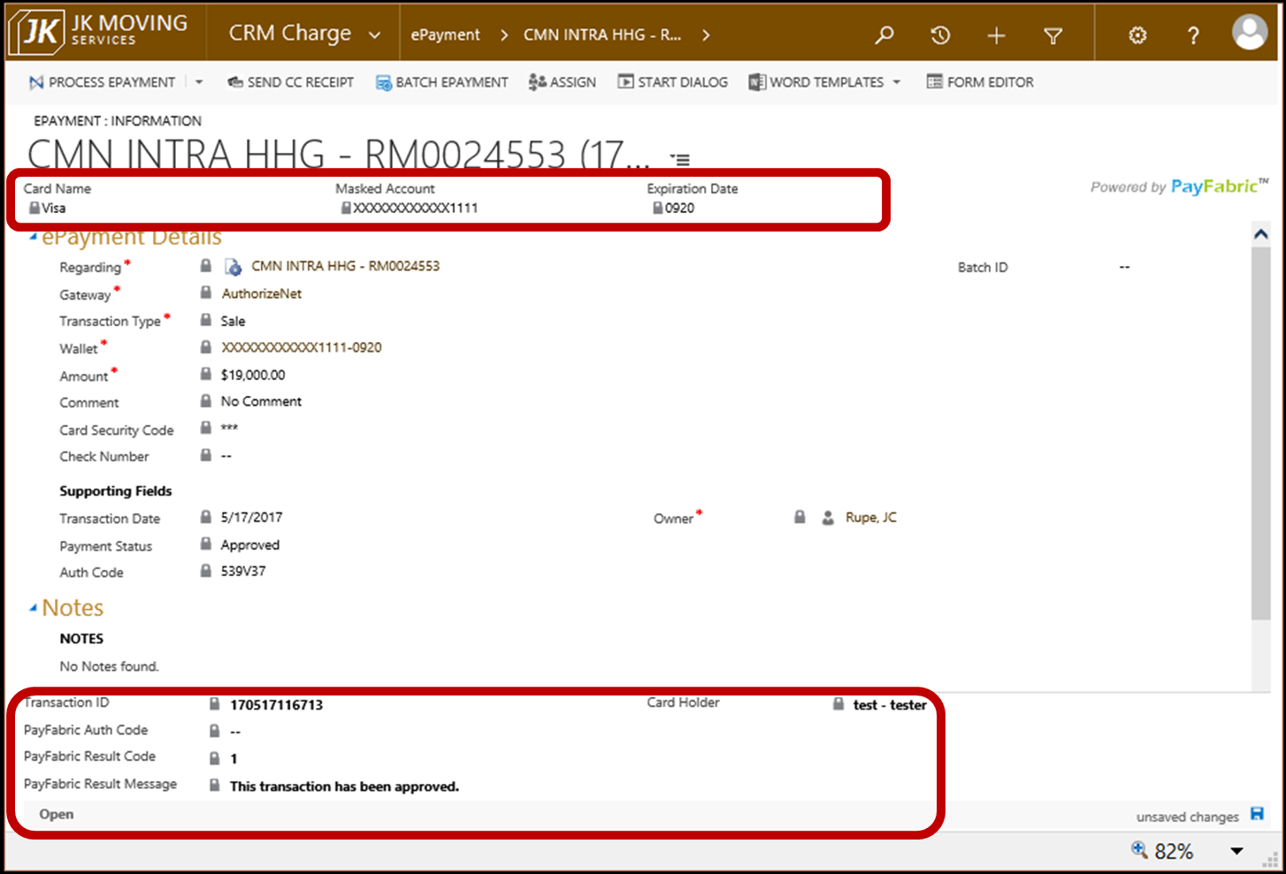

1. A credit card receipt may be sent by email to the Contact making the payment. Remain on the “Epayment: Information: page and see section Credit Card Receipt by Email.
   1. Also, see Verify Credit Card Receipt Sent by Email.
2. Close the “ePayment” page window.
3. To verify the ePayment, Navigate to the Contacts payment history page.
   1. See the steps in section View a Contacts Payment History.

### View a Contacts Payment History

1. Navigate to the Contacts View page.
   1. See the steps in section “Navigate to Contacts” section of the “JIM – Customer Service Reference Guide” document.
2. Search for the desired Contact.
   1. See the steps in section “Search for a Contact” section of the “JIM – Customer Service Reference Guide” document.
3. Open the desired Contact record, by double clicking on it.
4. The “Contact: Customer” page will display.
5. Select the down arrow next to the Contact’s name in the top menu bar.
   1. Select the “ePayment” option in the dropdown menu.

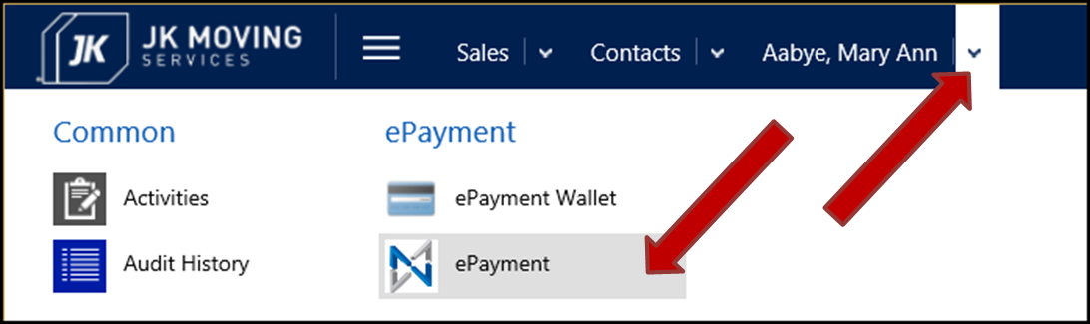

1. The “ePayment Associated View” will display on the “Contact: Customer” page.
2. The Contacts payment history will display in the record table.

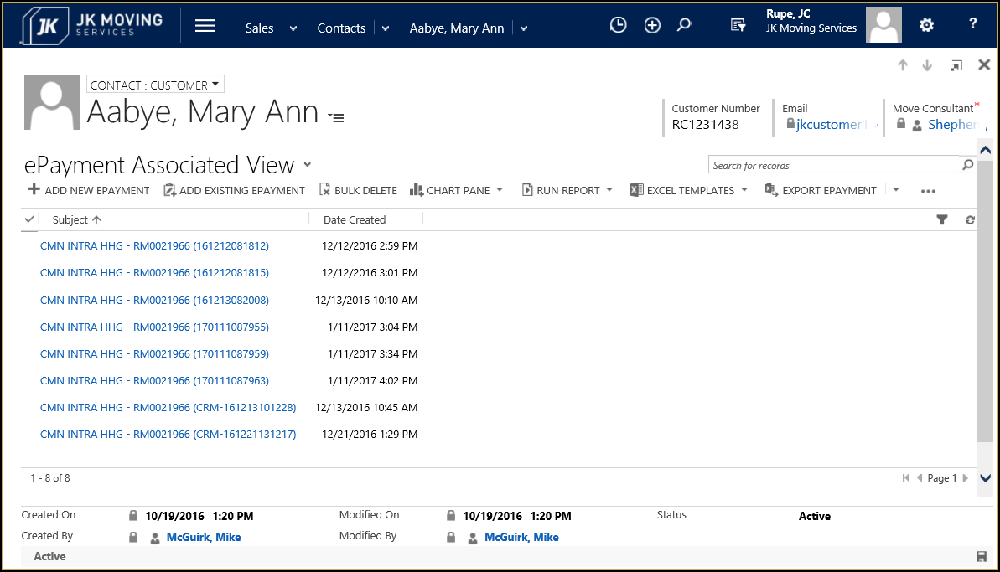

### View all ePayment Transactions

1. Select the “Main” menu button.
2. Select the “CRM Charge” Work Area.
3. Locate and select the “ePayment” Area under the “CRM Charge” column.

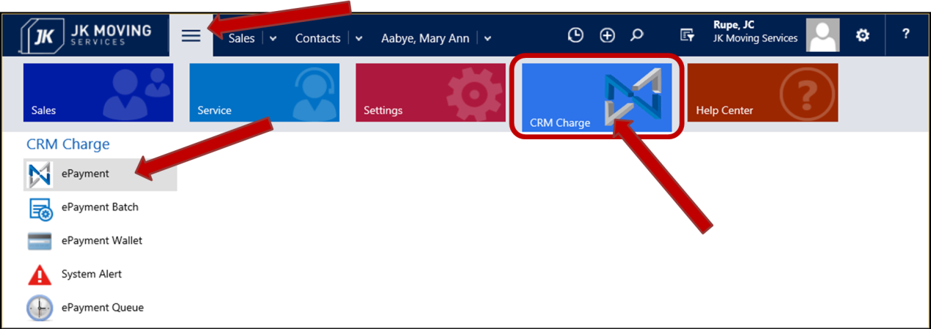

1. The “Approved Transactions – This Month” View page will display.

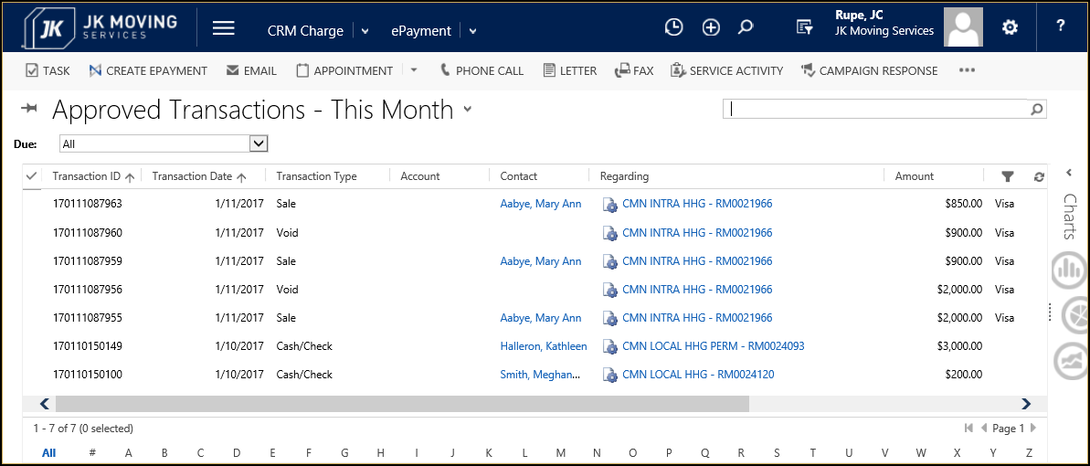

### Void a Payment

A charge card payment may only be voided on the day the transaction was entered into the system.

1. Navigate to the Contacts payment history page.
   1. See the steps in section View a Contacts Payment History.
2. Locate and open the transaction to be voided.
   1. Double click on the desired transaction.
3. Select the “Process ePayment” button in the upper left of the page.

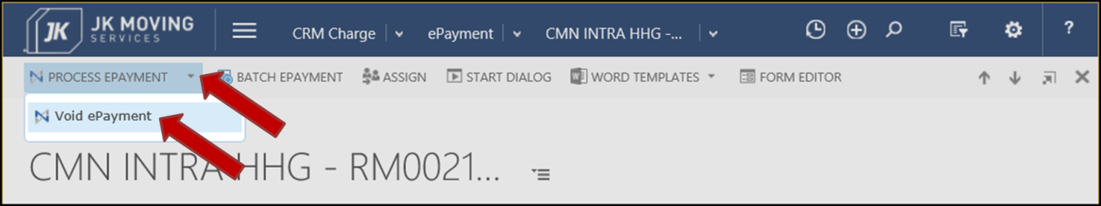

1. Select the “Void ePayment” option from the dropdown menu.
2. A message box will display, when the charges are successfully processed.
   1. Verify that the Status is “Approved”.
   2. The Auth Code will be the same as the original transaction.
   3. Select the “OK” button.

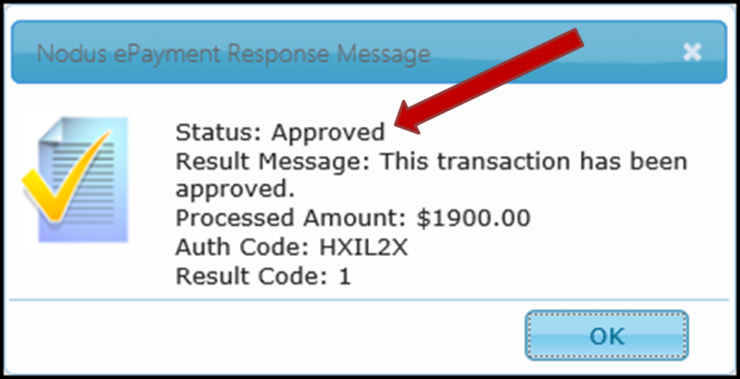

1. The “ePayment: Information” page will redisplay.

### Results of Voiding a Transaction the Next Day

A charge card payment may only be voided on the day the transaction was entered into the system.

1. If an attempt is made to void a charge card payment after the day it was created, the Void will be declined.
   1. This is a picture of the Response Message for a Declined transaction:

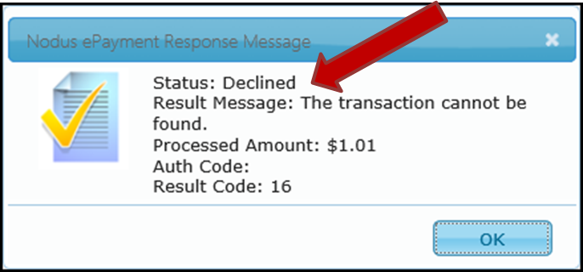

### Credit Card Receipt by Email

1. Navigate to the desired “ePayment: Information” page.
2. Select the “Send CC Receipt” button near the upper left of the page.

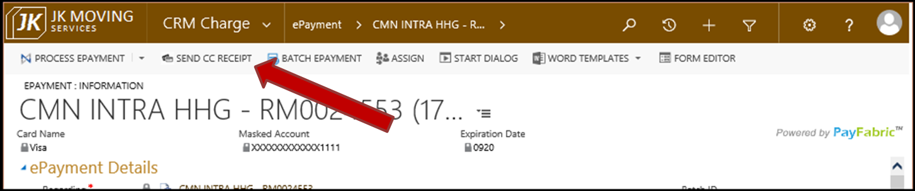

1. A message window will display saying that the receipt was successfully sent.
   1. Select the “OK” button.

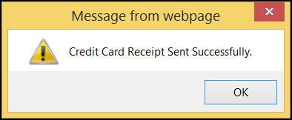

1. Close the “ePayment: Information” page.

### Verify Credit Card Receipt Sent by Email

1. Navigate to the “Activities” page.
   1. From the main menu select “Service”, then Activities (under My Work column).
2. The Activities page will be displayed.
3. Select to view all emails.
   1. Select the down arrow next to the Activities page heading.
   2. Select the “Email” option.
   3. Select the “All Emails” option.

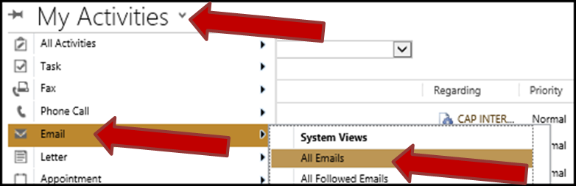

1. Locate the desired email payment.
   1. Note that the Status Reason is “Sent”. This indicates that the email was sent out to the recipient.

